27.20: (a) 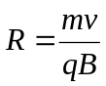
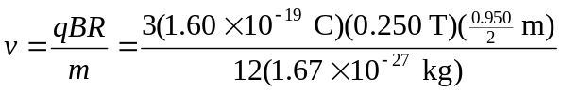
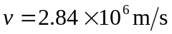
Since 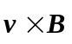is to the left but the charges are bent to the right, they must be negative.
b)
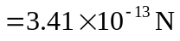
Since 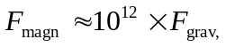 we can safely neglect gravity.
c) The speed does not change since the magnetic force is perpendicular to the velocity and therefore does not do work on the particles.

